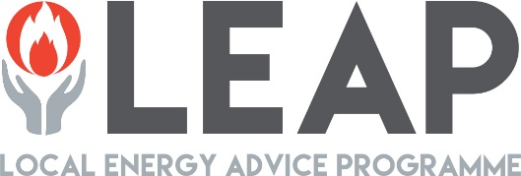

LEAP is a free service providing advice, support and energy saving measures to fuel poor and vulnerable households across Merseyside and Cheshire.

Eligibility Criteria

The scheme is open to all types of householders – homeowners, private renters and social housing tenants. They only need to qualify on one of the categories below in order to be eligible for the scheme.

Income Criteria – anyone with one or more of the following:

- Income Support
- Income-related Jobseeker's Allowance
- Income-related Employment & Support Allowance
- Pension Credit
- Child Tax Credit
- Working Tax Credit with an income below £16,190
- Universal Credit with an income below £16,190
- Income below £16,190

Physical Health Criteria – anyone with one or more of the following:

- Cardiovascular condition (incl. coronary heart disease, stroke, hypertension, transient ischemic attack)
- Respiratory condition (COPD, childhood asthma)
- Neurological condition (incl dementia, Parkinson’s disease, multiple sclerosis, epilepsy)
- Musculoskeletal conditions (incl. osteoarthritis, rheumatoid arthritis etc)
- Blood conditions (incl. Sickle cell disease, thalassemia)
- Cancer
- Physical or sensory disability
- Other illness exacerbated by cold (confirmed by GP)
​

Mental Health Criteria, such as:

- Schizophrenia
- Bipolar disorder
- Serious depression (receiving regular treatment)

Vulnerability Criteria – anyone with one or more of the following:

- Carers in receipt of carers allowance
- Housing Benefit
- Council Tax Reduction
- Disability benefit e.g. Disability Living Allowance, Personal Independence Payment, Attendance Allowance, Industrial Injuries Disablement Benefit
- Contribution-based ESA or JSA
- Vulnerable family situation such as victim of domestic violence or recent bereavement
- Household with maternity/ child under 5 or particularly large family.

Making a Referral to LEAP

You can refer a householder to LEAP using the Energy Projects Plus referral form, which can be emailed to advice@epplus.org

Alternatively, you can call the Save Energy Advice Line on 0800 043 0151.

